Advance Care Planning

Free Level 1a One Day Workshop

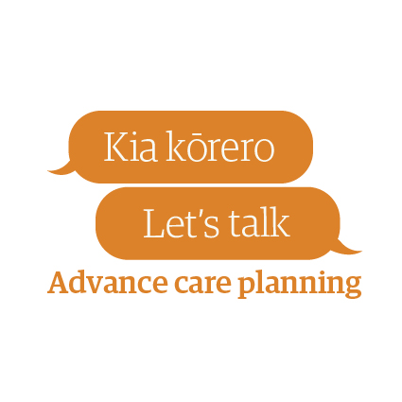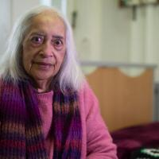

Monday 11th February 2020
8.15am - 4.pm

Presenter: Clarice Alderdice
Venue: Poutama Learning Center, Gisborne Hospital

Learn how to translate an individual’s wishes into written documentation for their advance care planning

Gain experience in supporting patients with ACP

Please note: Course pre-requisite: ACP eLearning needs to be completed before attending the workshop. https://acp.elearning.ac.nz

To register contact Heather Robertson: Heather.Robertson@tdh.org,nz

Closing date to register 10th January 2020

